Case Study No: 3
Experiment Title: Implement the given problem statements using JavaScript using Conditional Statement.
Case Study Title: WAP to output Grade “C” if entered marks are between 50-65, “B” for 66-80, “A” for 80-90 and “A+” for above 90.
Software/ Tools Required: VS Code (text editor), HTML, CSS, JavaScript.
Case Study Program Code:
Index.html –
<!DOCTYPE html>
<html lang="en">
<head>
<meta charset="UTF-8">
<meta name="viewport" content="width=device-width, initial-scale=1.0">
<title>Student Grading System</title>
<!-- CSS File ko link kiya hai -->
<link rel="stylesheet" href="style.css">
</head>
<body class="login-theme"> <!-- Starts with login theme -->
<div class="container">
<!-- ================= LOGIN SECTION ================= -->
<div id="loginSection">
<h2>Portal Login</h2>
<form id="loginForm">
<div class="form-group">
<label for="loginPrn">PRN:</label>
<input type="text" id="loginPrn" placeholder="Enter 11-digit PRN" maxlength="11" required>
</div>
<div class="form-group">
<label for="loginPassword">Password:</label>
<input type="password" id="loginPassword" placeholder="Enter password" required>
<!-- Small dynamic message box for password conditions -->
<div id="passwordError" class="input-error-msg"></div>
</div>
<div class="btn-group">
<button type="button" class="btn btn-submit" onclick="handleLogin()">Login</button>
</div>
</form>
</div>

<!-- ================= GRADING SECTION ================= -->
<div id="gradingSection" style="display: none;">
<h2>Student Grading System</h2>
<form id="gradeForm">
<div class="form-group">
<label for="name">Student Name:</label>
<input type="text" id="name" placeholder="Enter student name" required>
</div>
<div class="form-group">
<label for="prn">PRN:</label>
<input type="text" id="prn" readonly>
</div>
<div class="form-group">
<label for="marks">Marks (0-100):</label>
<input type="number" id="marks" placeholder="Enter marks" min="0" max="100" required>
</div>
<div class="btn-group">
<button type="button" class="btn btn-submit" onclick="gradeSystem()">Calculate Grade</button>
<button type="button" class="btn btn-clear" onclick="clearForm()">Clear</button>
</div>
</form>
<!-- Dynamic Left-Aligned Result Box -->
<div id="result" class="result-box"></div>

<!-- Logout Button -->
<button type="button" class="btn btn-logout" onclick="handleLogout()">Logout</button>
</div>
</div>

<footer class="site-footer">
<hr>
<p><strong>Created by:</strong> Ritisha Naigaonkar-045, A2 Batch</p>
</footer>

<!-- JavaScript File ko link kiya hai -->
<script src="script.js"></script>
</body>
</html>

style.css –
* {
margin: 0;
padding: 0;
box-sizing: border-box;
font-family: 'Segoe UI', Tahoma, Geneva, Verdana, sans-serif;
}

/* ================= STANDARD GRADING PAGE THEME ================= */
body {
background: linear-gradient(135deg, #f7f3ea 0%, #e3d7c3 50%, #cfbf9e 100%);
min-height: 100vh;
display: flex;
flex-direction: column;
justify-content: center;
align-items: center;
padding: 20px;
transition: background 0.4s ease, color 0.3s ease;
}

/* ================= DARKER LOGIN PAGE THEME ACCENTS ================= */
body.login-theme {
background: linear-gradient(135deg, #bfae93 0%, #9c8a6f 50%, #7d6b52 100%);
}

body.login-theme h2 {
color: #1a140c;
}

body.login-theme label {
color: #241c11;
}

body.login-theme .site-footer {
color: #241c11;
text-shadow: none;
}

body.login-theme .site-footer hr {
border-top: 1px solid rgba(0, 0, 0, 0.2);
}

/* ================= MAIN CONTAINER AND INNER OBJECTS ================= */
.site-footer {
width: 100%;
max-width: 450px;
margin-top: 30px;
text-align: center;
font-size: 15px;
color: #4a4135;
text-shadow: 0 1px 2px rgba(255, 255, 255, 0.6);
}

.site-footer hr {
border: none;
border-top: 1px solid rgba(92, 80, 64, 0.2);
margin-bottom: 15px;
}

.container {
background: #ffffff;
padding: 30px;
border-radius: 16px;
box-shadow: 0 15px 35px rgba(92, 80, 64, 0.25), inset 0 0 0 1px rgba(255, 255, 255, 0.6);
width: 100%;
max-width: 450px;
}

h2 {
color: #42382b;
margin-bottom: 25px;
text-align: center;
font-size: 1.7rem;
font-weight: 700;
letter-spacing: -0.5px;
}

.form-group {
margin-bottom: 18px;
position: relative;
}

label {
display: block;
margin-bottom: 7px;
color: #5c5040;
font-weight: 600;
font-size: 0.9rem;
}

input[type="text"],
input[type="number"],
input[type="password"] {
width: 100%;
padding: 12px;
border: 2px solid #eadecc;
border-radius: 8px;
font-size: 1rem;
background-color: #faf8f5;
transition: all 0.3s ease;
}

input[type="text"]:focus,
input[type="number"]:focus,
input[type="password"]:focus {
outline: none;
border-color: #baa887;
background-color: #ffffff;
box-shadow: 0 0 0 4px rgba(186, 168, 135, 0.15);
}

input[readonly] {
background-color: #f1ebd8;
color: #7a6e5d;
cursor: not-allowed;
border-color: #e5decb;
}

.input-error-msg {
display: none;
margin-top: 8px;
padding: 10px;
background-color: #fdf5f5;
color: #a63232;
border-left: 3px solid #d9534f;
border-radius: 4px;
font-size: 0.82rem;
line-height: 1.4;
text-align: left;
}

.btn-group {
display: flex;
gap: 12px;
margin-top: 25px;
}

.btn {
flex: 1;
padding: 14px;
border: none;
border-radius: 8px;
font-size: 1rem;
font-weight: bold;
cursor: pointer;
box-shadow: 0 4px 10px rgba(0, 0, 0, 0.05);
transition: all 0.3s ease;
}

.btn-submit {
background: linear-gradient(135deg, #cfbf9e, #baa887);
color: white;
text-shadow: 0 1px 2px rgba(0, 0, 0, 0.1);
}

.btn-submit:hover {
background: linear-gradient(135deg, #c4b391, #ad9b79);
transform: translateY(-1px);
box-shadow: 0 6px 14px rgba(186, 168, 135, 0.3);
}

.btn-clear {
background: linear-gradient(135deg, #f7f5f0, #eae4d8);
color: #5c5040;
border: 1px solid #e5decb;
}

.btn-clear:hover {
background: linear-gradient(135deg, #eae4d8, #ded5c2);
transform: translateY(-1px);
}

.btn-logout {
background: transparent;
color: #8a7a63;
font-size: 0.9rem;
margin-top: 20px;
padding: 8px;
box-shadow: none;
border: 1px dashed #cfbf9e;
width: 100%;
}

.btn-logout:hover {
background-color: #fdfaf2;
color: #5c5040;
}

/* Dynamic Left-Aligned Result Box Styles */
.result-box {
margin-top: 25px;
padding: 22px;
border-radius: 10px;
text-align: left;
font-weight: 600;
display: none;
box-shadow: 0 6px 15px rgba(0, 0, 0, 0.03);
}

.report-row {
display: flex;
justify-content: flex-start;
margin-bottom: 10px;
font-size: 0.95rem;
}

.report-label {
width: 140px;
display: inline-block;
color: #6e614e;
}

.report-value {
color: #2b241a;
}

.report-header {
text-align: left;
margin-bottom: 18px;
border-bottom: 2px dashed rgba(92, 80, 64, 0.15);
padding-bottom: 10px;
}

.report-header h3 {
font-size: 1.2rem;
color: #42382b;
letter-spacing: 1px;
}

.report-header h5 {
font-size: 0.85rem;
color: #8a7a63;
font-weight: 500;
margin-top: 2px;
}

.report-footer {
margin-top: 15px;
padding-top: 10px;
border-top: 2px dashed rgba(92, 80, 64, 0.15);
color: #42382b;
}

/* High-end Muted Alert Cards */
.success {
background: linear-gradient(135deg, #f3f6f0, #e6edd9);
color: #2e3d19;
border: 1px solid #cbdba8;
}

.warning {
background: linear-gradient(135deg, #fdfaf2, #f9f0d7);
color: #54431d;
border: 1px solid #e6d3a1;
}

.danger {
background: linear-gradient(135deg, #fbf5f5, #f6e6e6);
color: #6e2424;
border: 1px solid #e6bcbc;
}

script.js –
alertClass = "warning";
} else {
grade = "Fail (Below 50)";
alertClass = "danger";
}

resultDiv.innerHTML = `
<div class="report-header">
<h3>REPORT CARD</h3>
<h5>Academic Evaluation Summary</h5>
</div>
<div class="report-row">
<span class="report-label">Student Name:</span>
<span class="report-value"><u>${name}</u></span>
</div>
<div class="report-row">
<span class="report-label">PRN:</span>
<span class="report-value"><u>${prn}</u></span>
</div>
<div class="report-row">
<span class="report-label">Marks Obtained:</span>
<span class="report-value"><u>${marks} / 100</u></span>
</div>
<div class="report-row">
<span class="report-label">Final Grade:</span>
<span class="report-value grade-highlight"><u>${grade}</u></span>
</div>
<div class="report-footer">
<span>Status: <u>${marks >= 50 ? 'PASSED' : 'FAILED'}</u></span>
</div>
`;

resultDiv.className = "result-box " + alertClass;
resultDiv.style.textAlign = "left";
resultDiv.style.display = "block";
}

function clearForm() {
document.getElementById("gradeForm").reset();
document.getElementById("prn").value = document.getElementById("loginPrn").value.trim();
var resultDiv = document.getElementById("result");
resultDiv.style.display = "none";
}

function handleLogout() {
document.getElementById("loginForm").reset();
document.getElementById("gradeForm").reset();
document.getElementById("result").style.display = "none";
document.getElementById("passwordError").style.display = "none";

// Add the darker login background theme back on logout
document.body.classList.add("login-theme");
document.getElementById("gradingSection").style.display = "none";
document.getElementById("loginSection").style.display = "block";
}

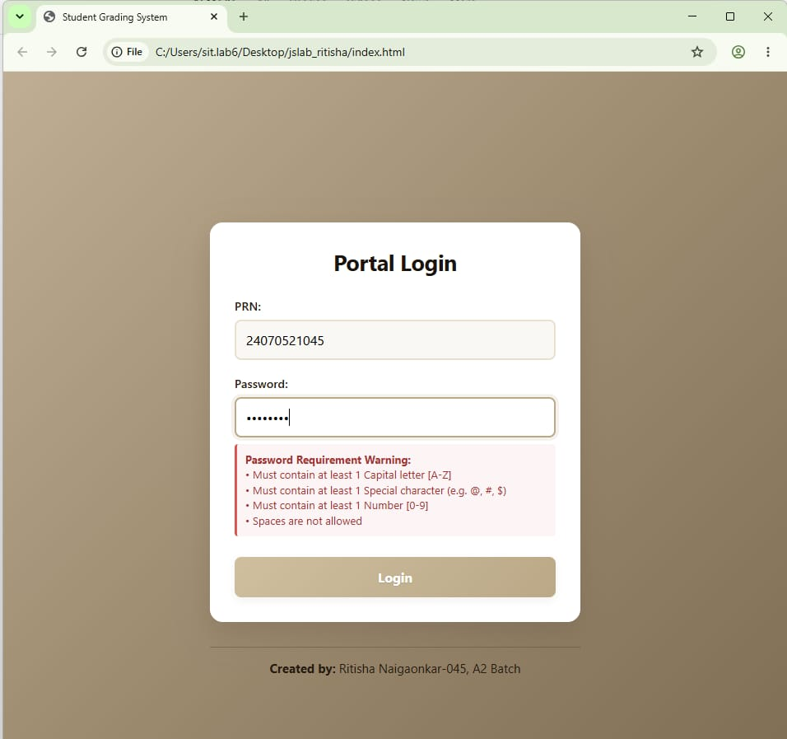
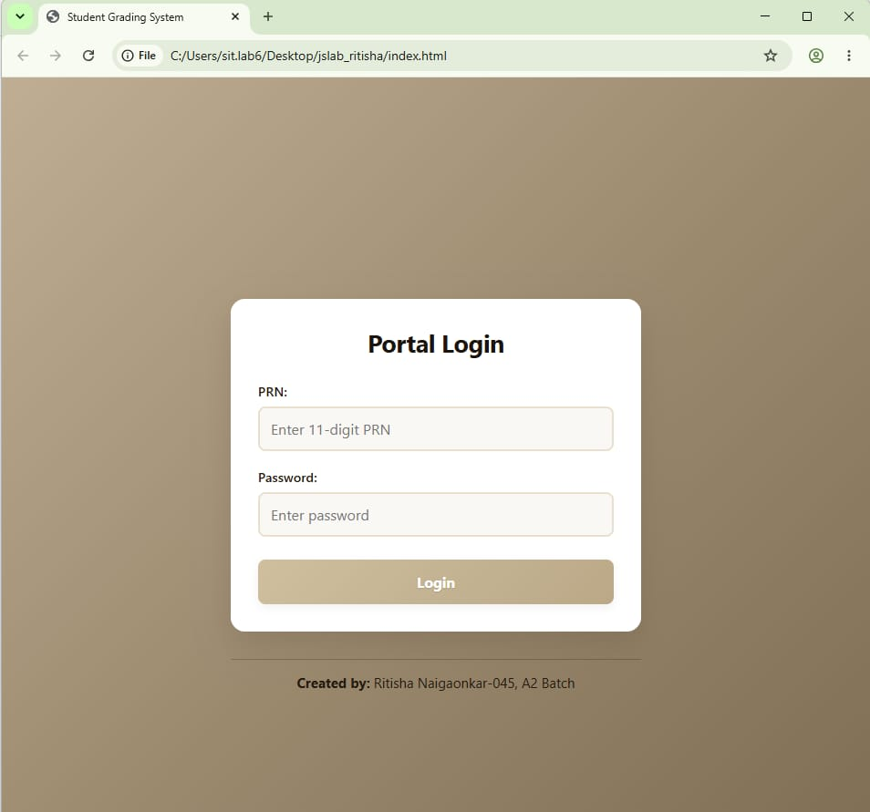
Output:

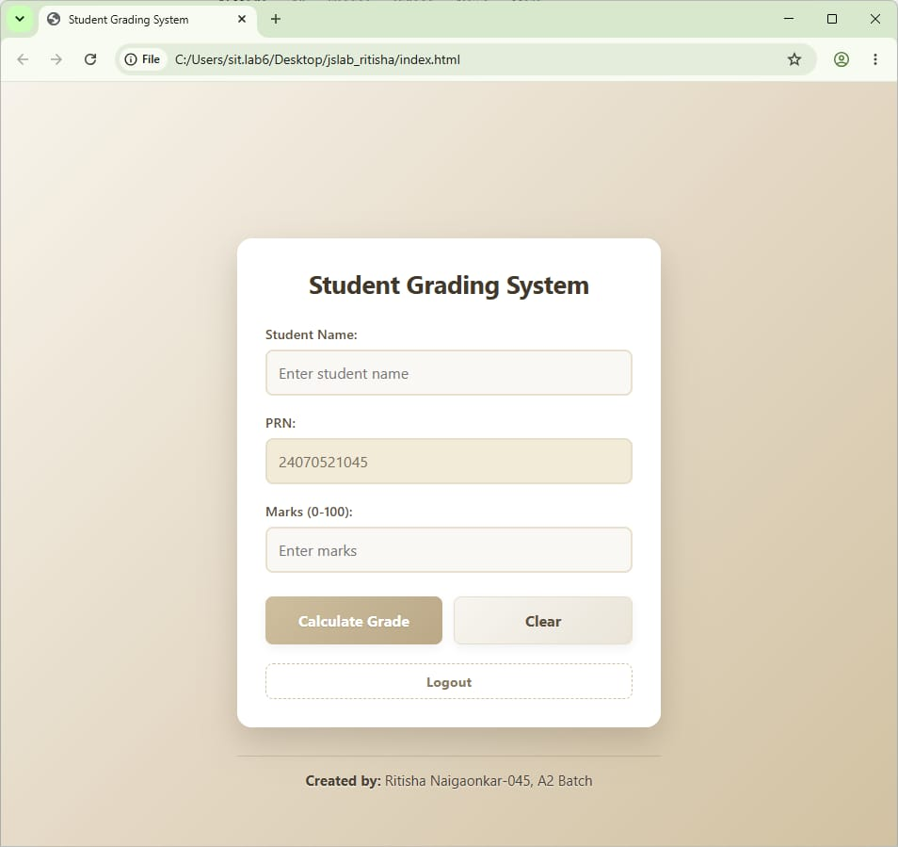
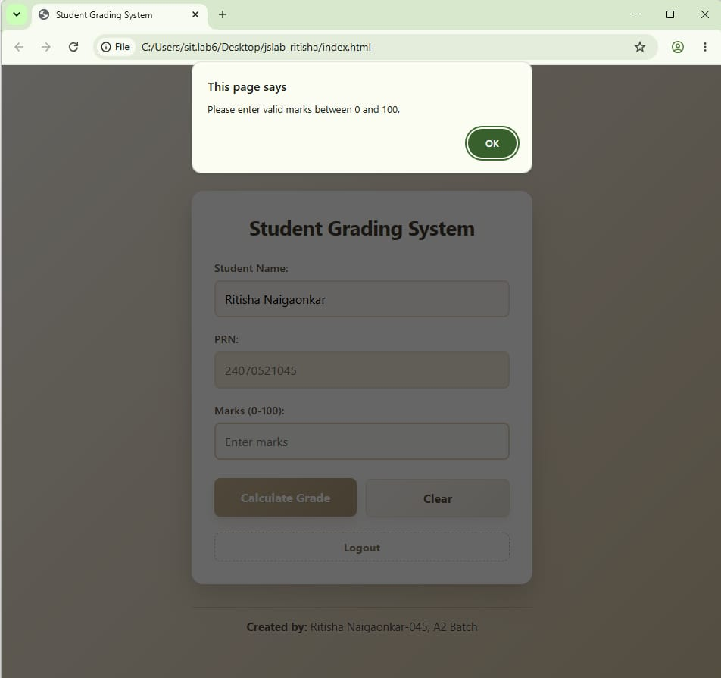

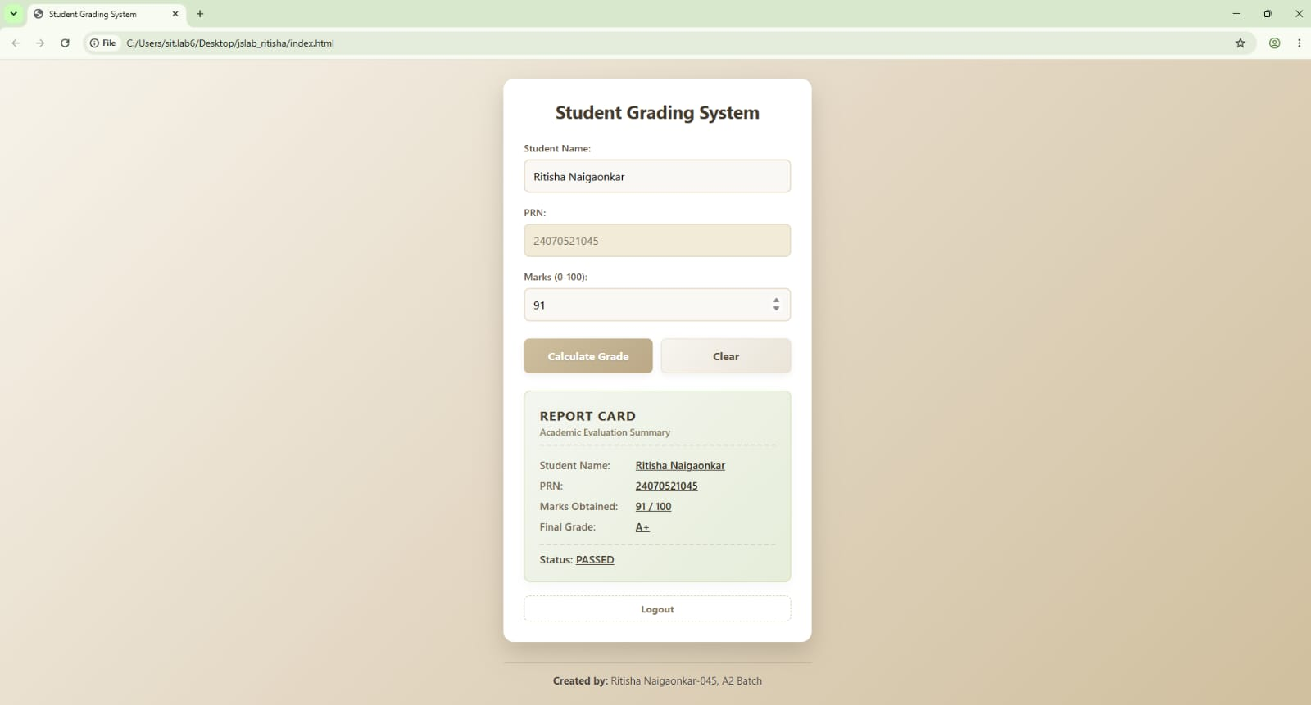
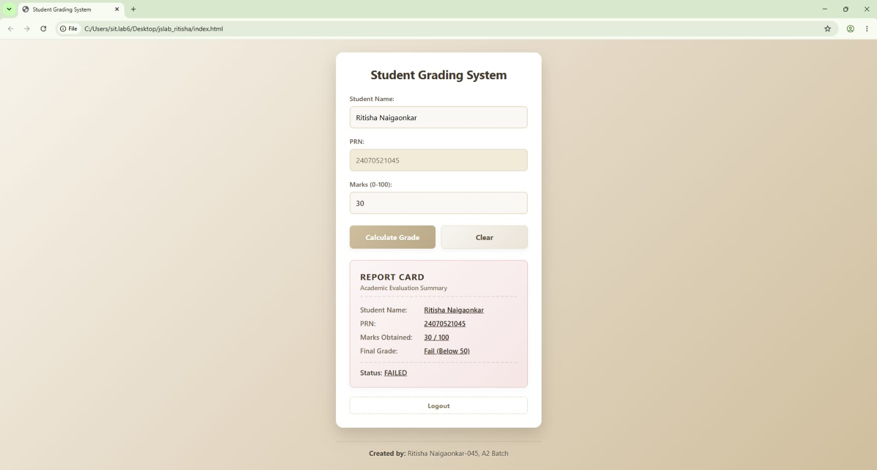

Result/ Conclusion: Thus a JavaScript program to calculate and display the student's grade based on marks entered was successfully implemented using conditional statements, and the desired output was verified.
Ritisha Naigaonkar, Sem-5 A2, 24070521045

